Sequence Conservation, Structural Contact Analysis, and Molecular Docking Tested as Predictors of Methotrexate-Resistance Affinity Changes in Human Dihydrofolate Reductase
Bidhan Kundu Protick¹*
¹ Department of Genetic Engineering and Biotechnology, Shahjalal University of Science and Technology, Sylhet-3114, Bangladesh
* Corresponding author. Email: 2022431001@student.sust.edu. ORCID: https://orcid.org/0009-0004-4368-5828

Highlights
- Rigid-receptor AutoDock Vina docking of four human DHFR resistance mutants recovered the correct direction of methotrexate binding disruption in only 1 of 4 cases (Pearson r = −0.54 vs. published affinity data).
- Allowing the mutated side chain(s) to relax (flexible docking) improved direction agreement to 2 of 4 mutants (Spearman ρ = 0.80), though both correlations are exploratory at n = 4.
- An expanded 200-sequence ortholog panel ranked the four resistance positions by conservation percentile and Grantham physicochemical distance, rather than by six-species presence/absence alone.
- Reanalysis of GEO dataset GSE11440 with limma confirmed DHFR transcript upregulation in methotrexate-resistant HT29 cells with substantially stronger statistical confidence than a per-probe Welch’s t-test.
- DHFR’s expression shift co-occurs with coordinated changes in other folate-pathway transcripts, including the methotrexate transporter SLC19A1.

Abstract
Dihydrofolate reductase (DHFR) is a folate-pathway enzyme and a classical methotrexate (MTX) target in cancer chemotherapy. Clinical resistance to methotrexate arises through at least two independent mechanisms: point mutations that reduce the enzyme’s affinity for the drug, and increased DHFR gene expression or copy number that raises the number of target molecules per cell. This study asks whether sequence conservation, structural ligand-contact analysis, and molecular docking — validated directly against published biochemical affinity data — can explain the reduced methotrexate binding of four well-characterized human DHFR resistance mutants (L22F, L22Y, F31R/Q35E, Q35S/N64S), and how this enzyme-level mechanism compares to the transcriptional/amplification-driven resistance captured by expression analysis. An expanded panel of 200 DHFR orthologs (23 reviewed UniProt/Swiss-Prot entries plus 177 taxonomically diverse UniProt/TrEMBL entries spanning bacteria to mammals, capped at three sequences per genus) let per-residue conservation (Shannon entropy, percent identity, and Grantham physicochemical distance of tolerated substitutions) be ranked against the rest of the protein: Leu22 was more conserved than the protein-wide average (76th percentile among the other 182 scored positions), while Phe31, Gln35, and Asn64 were each somewhat less conserved (20th, 34th, and 26th percentile, respectively), and naturally tolerated substitutions at Phe31 were physicochemically smaller than the known F31R resistance mutation, while at Leu22 and Gln35 they were comparable in magnitude to the resistance mutations there. AutoDock Vina redocking of methotrexate into the wild-type crystal structure (PDB 1U72) reproduced the experimental pose (RMSD = 1.12 Å) and a realistic affinity (−10.21 kcal/mol). Rigid-receptor docking into the four mutant structures matched the experimentally observed direction of binding disruption for only 1 of 4 mutants (Pearson r = −0.54 against published affinity changes, not statistically significant at this sample size); allowing the mutated side chain(s) to relax (flexible docking) improved this to 2 of 4 (Spearman ρ = 0.80), consistent with structurally documented alternate side-chain conformers in one mutant (PDB 3EIG) and a likely kinetic (dissociation-rate) rather than equilibrium mechanism in another. Independently, differential expression analysis of a public microarray dataset (GEO GSE11440; methotrexate-resistant vs. sensitive HT29 colon cancer cells) showed DHFR transcript abundance increased 7.48-fold in resistant cells (log2 fold-change = 2.90), significant under both a per-probe Welch’s t-test (adjusted p = 0.048) and, more strongly, under a limma empirical-Bayes reanalysis (adjusted p = 0.0083) — occurring alongside coordinated shifts in other folate-pathway transcripts, notably the methotrexate transporter SLC19A1 — consistent with the amplification-driven mechanism reported for this cell line, though this dataset alone cannot establish gene amplification. Together, these analyses show that mutation-driven and expression-driven methotrexate resistance are mechanistically distinct, each requiring its own class of evidence rather than a single predictive computational method. The central finding is that static docking is useful for mechanistic interpretation — explaining, case by case, why specific mutants behave as they do — but is a poorly calibrated quantitative predictor of methotrexate affinity change, with side-chain flexibility improving qualitative agreement in only some mutants.

1. Introduction
Dihydrofolate reductase (EC 1.5.1.3) catalyzes the NADPH-dependent reduction of dihydrofolate to tetrahydrofolate, a reaction required for the synthesis of purines, thymidylate, and several amino acids. Because rapidly dividing cells depend heavily on this pathway, DHFR has been a chemotherapeutic target since the earliest era of antifolate drug design, most notably for methotrexate (MTX), a folate analog that binds DHFR roughly 1,000-fold more tightly than the natural substrate. Despite decades of clinical use, the utility of methotrexate is limited by the development of resistance, which arises through several distinct cellular mechanisms rather than a single one.
Two mechanisms dominate the literature. The first is enzyme-level: point mutations in the DHFR coding sequence, typically at active-site residues that contact the pteridine or glutamate moiety of methotrexate, which reduce the enzyme’s binding affinity for the drug directly [1,2]. The second is cellular-level: increased DHFR gene expression, frequently via gene amplification, which increases the number of target enzyme molecules per cell without necessarily changing the enzyme’s intrinsic affinity for the drug at all [3]. These two mechanisms act at fundamentally different biological levels — protein structure versus gene copy number/transcription — and are supported by different classes of evidence: biochemical/structural/computational evidence for the former, transcriptomic (and, ideally, genomic) evidence for the latter.
This project asks a specific, testable question: can sequence conservation, structural ligand-contact analysis, and molecular docking — validated against published biochemical affinity data — explain the reduced methotrexate binding of well-characterized human DHFR resistance mutations, and how does this enzyme-level mechanism compare to the transcriptional/amplification-driven resistance captured by expression analysis?
DHFR is a well-suited case study for this question for three reasons. First, it is highly conserved across the tree of life, making cross-species sequence and structural comparison informative rather than trivial. Second, it has several experimentally solved crystal structures of both wild-type and resistance-mutant enzyme in complex with methotrexate, which allows structural and docking analysis to be grounded in real, not modeled, mutant conformations. Third, its overexpression in cancer is a textbook example of a distinct, expression-driven resistance mechanism, allowing the two mechanisms to be studied side by side using the same protein and drug.
Previous studies established which DHFR mutations confer methotrexate resistance and characterized their biochemical consequences individually, but did not test whether standard computational descriptors of protein structure predict the size of the resulting affinity change. Here, we integrate evolutionary conservation across an expanded ortholog panel, experimentally determined mutant crystal structures, validated wild-type ligand redocking, flexible-side-chain docking, and independent transcriptomic analysis to run exactly that test, across a ten-module computational pipeline. An initial six-species retrieval, BLASTp homology search, sequence alignment, and phylogenetic reconstruction (Modules 1, 2, 3, and 4) were superseded for the primary conservation analysis by an expanded, 200-sequence ortholog panel (Module 8) once a larger, statistically powered comparison set was needed; the original modules are retained as Supplementary Material. The pipeline then covers structural retrieval and ligand-contact analysis of wild-type and mutant DHFR (Module 5), molecular docking validated against published affinity data (Module 6), and differential gene expression analysis of a resistant-versus-sensitive cell line model — first by Welch’s t-test (Module 7), then by the field-standard limma empirical-Bayes method (Module 9), and by unsupervised PCA and pathway-level clustering (Module 10).

2. Materials and Methods

2.1 Ortholog retrieval for conservation scoring (Module 8)
DHFR orthologs were retrieved directly from the UniProt REST API (gene:DHFR AND reviewed:true, paginated), length-filtered to 150–260 aa to exclude bifunctional dihydrofolate reductase–thymidylate synthase fusion proteins found in plants, kinetoplastid parasites, and apicomplexans, which run 2–4× longer than a monofunctional DHFR domain. Because the reviewed (Swiss-Prot) set alone yielded only 23 sequences, it was supplemented with taxonomically diverse unreviewed (TrEMBL) entries (reviewed:false, same length filter), selected by round-robin across genera capped at three sequences per genus to avoid over-representing heavily sequenced model organisms, for a final deduplicated panel of 200 sequences spanning six taxonomic groups (Table 1). This superseded an earlier, smaller six-species retrieval (Bio.Entrez; Homo sapiens, Mus musculus, Rattus norvegicus, Danio rerio, Saccharomyces cerevisiae, Escherichia coli), BLASTp homology screen [4], and MAFFT alignment [5] used only for phylogenetic reconstruction (Module 4) — retained as Supplementary Table S1 and Supplementary Figure S1, respectively.

2.2 Multiple sequence alignment and conservation scoring (Module 8)
The 200-sequence panel was aligned with MAFFT v7.526 (mafft --auto) [5]. At every alignment column mapping to a non-gap human residue (mature-protein numbering, Met1 cleaved), Shannon entropy, percent identity to the human wild-type residue, the observed substitution spectrum, and mean Grantham physicochemical distance [6] (matrix values from the patterninstitute/grantham repository, github.com/patterninstitute/grantham) of sequences differing from wild-type were computed, giving 186 scored positions in total. The four positions later found to be mutated in the resistance structures (22, 31, 35, 64, mature-protein numbering) were compared against the distribution of the other 182 positions to express each as a percentile of conservation, and their tolerated natural substitutions’ Grantham distances were compared against the known resistance mutations at the same sites (L22R/F/Y/W, F31R, Q35E/S/K).

2.3 Phylogenetic reconstruction (Module 4)
A tree was built from the legacy six-species alignment (Module 1) using VeryFastTree v4.0.5, a parallelized, CLI-compatible reimplementation of FastTree2 [7,8]— disclosed here as this project’s substitute for FastTree itself, which has no macOS package. The tree was rooted on E. coli as outgroup, the most divergent sequence per the legacy BLASTp screen (Supplementary Table S1), and topology was checked programmatically (Bio.Phylo.BaseTree.Tree.is_monophyletic, Biopython [9]) against four expected clades: mammals, rodents, vertebrates, and eukaryotes. Homolog relationships were consistent with known species phylogeny (Supplementary Fig. S1), confirming the ortholog set used for conservation scoring was correctly assigned.

2.4 Structure retrieval and ligand-contact analysis (Module 5)
Five experimentally determined X-ray crystal structures of human DHFR were retrieved from the RCSB Protein Data Bank: wild-type 1U72 (1.9 Å, bound to methotrexate and NADPH), and four resistance mutants — 1DLR (L22F, 2.3 Å, bound to the methotrexate analog MXA), 1DLS (L22Y, 2.3 Å, bound to methotrexate), 3EIG (F31R/Q35E, 1.7 Å, bound to methotrexate), and 3F8Z (Q35S/N64S, 2.01 Å, bound to a non-methotrexate inhibitor, DH1/PY957). Because the mutant crystal structures were solved with different co-crystallized ligands prior to methotrexate redocking (e.g., MXA for L22F, DH1/PY957 for Q35S/N64S, versus MTX already present for WT, L22Y, and F31R/Q35E), differences in the starting conformational state of the binding pocket may contribute to docking score variability independent of the mutation’s true effect on methotrexate affinity. All four mutants were used as their own experimentally solved structures rather than as in-silico point mutations on the wild-type scaffold. Mutation identities were verified computationally by direct pairwise sequence comparison of each structure’s chain against 1U72, not taken from text descriptions. Residue-to-ligand distances were computed with Biopython’s Bio.PDB [9] as the minimum heavy-atom distance between each residue and the co-crystallized ligand, with contacts classified as “direct” (< 4.0 Å), “van der Waals” (4.0–5.0 Å) or “nearby” (up to 8.0 Å, for the full wild-type pocket scan).

2.5 Molecular docking (Module 6)
Methotrexate (PubChem CID 126941 [10]) was retrieved as a 3D SDF and converted to PDBQT with Open Babel v3.2.1 [11], Gasteiger charges, pH 7.4. Each of the five receptor structures was stripped of its co-crystallized ligand and water while retaining the NADPH cofactor where present, and converted to a rigid-receptor PDBQT. Docking was performed with AutoDock Vina v1.2.7 [12], search box 22 Å cubed centered on each structure’s own crystal ligand centroid, exhaustiveness 8, random seed 42 (fixed for reproducibility). Wild-type redocking was validated against the crystal pose using heavy-atom RMSD (obrms). A second docking pass used flexible side chains at exactly the residue(s) mutated in each structure, prepared with meeko v0.8.0 (mk_prepare_receptor.py) with default altloc ‘A’ where a structure contained alternate side-chain conformers; residues with crystallographically disordered/missing atoms (PDB REMARK 470) were excluded from the chemical-template matching step. Docking ΔΔG was computed as (mutant affinity − wild-type affinity); the equivalent experimental ΔΔG was computed from each source paper’s own published Ki fold-change as RT·ln(fold-change), R = 1.987 × 10⁻³ kcal mol⁻¹ K⁻¹, T = 298.15 K. Agreement between docking and experimental ΔΔG was summarized with Pearson and Spearman correlation, root-mean-square error (RMSE), mean absolute error (MAE), and sign agreement across all four mutants; because n = 4 is too small to support conventional inferential claims, a leave-one-out resampling check (excluding each mutant in turn) was used to assess the stability of the rigid-docking Pearson r specifically.

2.6 Differential expression analysis (Module 7)
A public microarray dataset, GEO accession GSE11440 (platform GPL570, Affymetrix Human Genome U133 Plus 2.0 Array; HT29 human colon adenocarcinoma cells, methotrexate-resistant vs. parental-sensitive, three biological replicates per group), was retrieved and parsed with GEOparse. Sample grouping was determined strictly from GEO’s own structured characteristics_ch1 metadata field (methotrexate sensitivity: resistant/sensitive), not inferred from sample titles; the pipeline was designed to fail with an explicit error rather than guess a label if this field were absent or ambiguous. Because the underlying data are Affymetrix MAS5 signal intensities rather than RNA-seq read counts, differential expression was computed as a log2-transform followed by a per-probe Welch’s t-test (resistant vs. sensitive) and Benjamini–Hochberg false-discovery-rate correction across all tested probes (scipy.stats, statsmodels), rather than a count-based method such as DESeq2, which would be inappropriate for intensity data.

2.7 limma reanalysis (Module 9)
Because Welch’s t-test estimates each probe’s variance independently from only three replicates per group — an inherently noisy estimate at this sample size — the same expression matrix and resistant-vs-sensitive grouping (Module 7) were reanalyzed with limma [13] via rpy2, calling R’s Bioconductor limma package directly rather than reimplementing its empirical Bayes moderation. A linear model was fit per probe with lmFit() on the same log2-transformed matrix used for the Welch’s t-test, a resistant-minus-sensitive contrast was extracted with contrasts.fit(), per-probe variances were moderated with eBayes(), and full results (log2 fold-change, moderated t-statistic, P-value, Benjamini–Hochberg-adjusted P-value) were extracted with topTable(number = Inf).

2.8 Principal component analysis and pathway-gene clustering (Module 10)
Unsupervised structure in the expression matrix (Module 7) was examined by principal component analysis (sklearn.decomposition.PCA [14]) on the top 2,000 most-variable probes (by variance of log2 signal across all six samples), without additional scaling. A second, hypothesis-driven view used one representative probe per gene (selected as in Module 7: preferring probes without extensive cross-hybridization risk, then the highest-expressed) for DHFR and six folate-pathway genes (TYMS, MTHFR, SLC19A1, GGH, FPGS, ATIC; probes identified from the GPL570 platform annotation, not assumed), z-scored per gene across the six samples and visualized as a hierarchically clustered heatmap (seaborn.clustermap [15]).

3. Results

3.1 Conservation across an expanded ortholog panel
A six-sequence alignment supports at most seven possible per-residue identity values — too few to rank individual positions against a meaningful background distribution. This was addressed with an expanded panel of 200 DHFR sequences: 23 reviewed (Swiss-Prot) entries, all within the 150–260 aa single-domain length range used to exclude bifunctional dihydrofolate reductase–thymidylate synthase fusion proteins (found in plants, kinetoplastid parasites, and apicomplexans such as Plasmodium), supplemented with 177 taxonomically diverse unreviewed (TrEMBL) entries — capped at three sequences per genus to avoid over-representing heavily sequenced model organisms — spanning six taxonomic groups (Table 1): 123 other-vertebrate, 34 mammal, 20 invertebrate, 10 bacteria, 9 other, and 4 fungal sequences. MAFFT alignment of this panel (561 columns) let per-position Shannon entropy, percent identity to the human wild-type residue, and mean Grantham physicochemical distance of tolerated substitutions be computed at all 186 human-mapped positions, so the four resistance positions could be ranked against the rest of the protein rather than reported in isolation (Figure 1).
Leu22 was more conserved than the protein average (Shannon entropy 0.74 bits vs. a protein-wide mean of 1.22 bits across the other 182 positions; 89.3% identity to wild-type; 76th percentile of conservation), while Phe31, Gln35, and Asn64 were each somewhat less conserved than average (entropy 1.82, 1.44, and 1.62 bits; 36.0%, 75.4%, and 74.6% identity; 20th, 34th, and 26th percentile, respectively) (Table 2). Physicochemically, natural substitutions tolerated at Phe31 (mean Grantham distance 27, predominantly Tyr and Met) were substantially smaller than the known F31R resistance mutation (Grantham distance 97); at Leu22 and Gln35, tolerated natural variation (mean Grantham distance 46 and 60) was of comparable magnitude to the known resistance mutations at those sites (mean Grantham distance 55 and 50, respectively, across the L22R/F/Y/W and Q35E/S/K substitution sets). No established resistance mutation is catalogued at Asn64 in the literature set used elsewhere in this study, though natural substitutions there were the most physicochemically diverse of the four positions (mean Grantham distance 108).

3.2 Structural context of the resistance positions
In the wild-type structure (1U72), a full pocket scan identified 17 residues in direct contact (< 4.0 Å) with bound methotrexate and 39 additional residues within 8.0 Å (Table 3, Figures 2–3). All four resistance positions were within direct contact distance of the bound ligand in wild-type (Leu22: 3.63 Å; Phe31: 3.44 Å; Gln35: 3.29 Å; Asn64: 2.76 Å), confirming their location within the substrate-binding pocket rather than a peripheral site.

3.3 Mutation-specific structural consequences
Across the four mutant structures, the mutated residue(s) remained in direct or near-direct contact with the bound ligand in every case except one: N64S in 3F8Z shifted to 4.21 Å (van der Waals range) from 2.76 Å in wild-type (Table 4, Figure 4). Notably, in 1DLR (L22F), the unmutated Gln35 shifted from 3.29 Å (wild-type) to 6.41 Å (outside direct-contact range) — an allosteric/conformational consequence of the L22F substitution on a neighboring, non-mutated pocket residue. Physicochemical characterization of each substitution (Table 5) showed L22F and N64S as chemically conservative (no charge or polarity change), L22Y as introducing a polarity change, F31R as introducing both a charge change (0 → +1) and a polarity change, Q35E as a charge change (0 → −1), and Q35S as the largest side-chain volume reduction of the set (−54.8 Å³).

3.4 Molecular docking
Wild-type redocking reproduced the crystallographic binding pose with a heavy-atom RMSD of 1.12 Å (below the conventional 2.0 Å success threshold) at a predicted affinity of −10.21 kcal/mol, validating the docking protocol before any mutant comparison was attempted (Table 6, Figure 5).
Rigid-receptor docking affinities for the four mutants were: 1DLR (L22F) −8.97 kcal/mol, 1DLS (L22Y) −10.39 kcal/mol, 3EIG (F31R/Q35E) −10.55 kcal/mol, and 3F8Z (Q35S/N64S) −8.98 kcal/mol (Table 7). Comparing the sign and magnitude of these changes against published Ki fold-changes (Table 8, Figure 6) showed rigid docking correctly predicted the direction of binding disruption for only 1 of 4 mutants (L22F, directionally consistent with the published aggregate resistance range, though the exact isolated Ki for this specific substitution could not be independently confirmed from an accessible primary source). Allowing the mutated side chain(s) to relax (flexible docking) improved this to 2 of 4: for F31R/Q35E, ΔΔG flipped from −0.34 kcal/mol (wrong direction) to +0.21 kcal/mol (correct direction, though below the published +3.86 kcal/mol magnitude); for Q35S/N64S, ΔΔG moved from +1.24 kcal/mol (over-predicting disruption) to +0.11 kcal/mol, much closer to the true near-zero experimental result. L22Y (1DLS) remained direction-inconsistent under both rigid and flexible docking (−0.18 and −0.35 kcal/mol respectively, versus a published +3.48 kcal/mol).
Metric | Rigid docking | Flexible docking
Pearson r | −0.54 (p = 0.47) | 0.29 (p = 0.71)
Spearman ρ | −0.11 (p = 0.90) | 0.80 (p = 0.20)
RMSE | 3.20 kcal/mol | 2.90 kcal/mol
MAE | 3.04 kcal/mol | 2.58 kcal/mol
Sign agreement | 1/4 | 2/4
Rigid-receptor docking scores were not only uncorrelated but weakly inversely correlated with the published experimental affinity changes (Pearson r = −0.54, n = 4), correctly recovering the sign of the effect in only 1 of 4 mutants. Allowing the mutated side chain(s) to relax (flexible docking) improved rank agreement (Spearman ρ = 0.80) and sign agreement (2 of 4), though the small sample size (n = 4) means these correlations are exploratory and not statistically significant (all p > 0.05) — a leave-one-out check showed the sign and magnitude of the Pearson r for rigid docking was unstable across subsets, underscoring that this is a qualitative, not quantitative, validation.

3.5 Transcriptomic comparison
Of 54,613 probes tested (Affymetrix control probes excluded) in the GSE11440 HT29 resistant-vs-sensitive comparison, 218 probes (0.40%) reached genome-wide significance by Welch’s t-test (adjusted p < 0.05; 116 up- and 102 down-regulated in resistant cells). DHFR transcript abundance was increased in the resistant group relative to the control group: representative probe 48808_at showed a log2 fold-change of 2.90 (7.48-fold increase), p = 1.88 × 10⁻⁴, adjusted p = 0.0481 — statistically significant at α = 0.05, ranking 214th of the 218 significant probes (i.e., just barely under the threshold). All four independent DHFR probes on the array agreed in direction and approximate magnitude (4.86- to 7.48-fold increase, all individually significant at adjusted p < 0.05), a consistent, non-cherry-picked result (Figure 7).
Because Welch’s t-test estimates each probe’s variance independently from only three replicates per group, the same matrix and grouping were reanalyzed with limma (lmFit/eBayes/contrasts.fit/topTable), which moderates each probe’s variance estimate by borrowing information across all probes tested. limma flagged 1,348 probes (2.5%) as significant genome-wide (668 up-, 680 down-regulated in resistant cells) — more than six-fold as many as Welch’s t-test, consistent with the expected power gain from variance moderation at this sample size. All four DHFR probes remained significant, and more strongly so: the representative probe (48808_at) moved from adjusted p = 0.0481 (214th of 218 significant probes, i.e. just barely under the threshold) under Welch’s t-test to adjusted p = 0.0083 (66th of 1,348 significant probes) under limma, with an unchanged log2 fold-change (2.90), since limma does not alter the underlying effect-size estimate, only its variance (Table 9). This is the textbook effect of empirical Bayes moderation on small-n microarray data: DHFR is significant under either method, but limma resolves it as a substantially more confident result rather than one sitting just under the α = 0.05 threshold.
To place the DHFR-specific finding in broader context, principal component analysis (PCA) on the top 2,000 most-variable probes showed resistant and sensitive samples separating cleanly along PC1 (44.0% of variance, no overlap between groups), while PC2 (15.3% of variance) did not track group identity (Figure 8) — i.e., resistance status is the dominant axis of transcriptional variation in this dataset, not a subtle effect competing with unrelated sources of variability. A clustered, per-gene z-scored heatmap of DHFR alongside six folate-pathway genes (TYMS, MTHFR, SLC19A1, GGH, FPGS, ATIC; representative probes selected per gene from the platform annotation) showed that DHFR’s shift is not an isolated change: GGH tracked it directly (Pearson r = +0.92 on per-gene z-scores), while SLC19A1 and ATIC moved strongly in the opposite direction (r = −0.99 and −0.92, respectively) — SLC19A1 encodes the reduced folate carrier that imports methotrexate into cells, so its coordinated downregulation in resistant cells is itself a recognized, independent resistance mechanism, not noise. TYMS, MTHFR, and FPGS showed only weak or inconsistent association with DHFR (r = +0.70, +0.44, and −0.27, respectively), so this coordinated response was not uniform across every folate-pathway gene tested (Figure 9).
This dataset contains no copy-number or array-CGH data (confirmed against its SuperSeries and all linked records); the observed result therefore supports increased DHFR transcript abundance but does not, by itself, establish gene amplification as its cause — amplification is cited here only as the mechanism reported in the original study of this cell line [3].

4. Discussion
The central research question asked whether sequence conservation, structural contact analysis, and docking — checked against real biochemical data rather than assumed — can explain reduced methotrexate binding in characterized human DHFR resistance mutants. The answer this pipeline supports is a qualified, evidence-based partially, not a clean yes.
None of the four resistance positions was absolutely invariant across the 200-sequence expanded ortholog panel (identity to human wild-type ranging from 36.0% at Phe31 to 89.3% at Leu22) — a finding consistent rather than contradictory with their role in methotrexate binding: positions tolerant enough to accept a resistance-conferring substitution in a living, viable cell line are, almost by definition, positions with real evolutionary tolerance for variation. That tolerance was graded rather than uniform: Leu22 sat well above the protein-wide average conservation (76th percentile), while Phe31, Gln35, and Asn64 sat somewhat below it (20th–34th percentile), and the physicochemical size of naturally tolerated substitutions at Phe31 was clearly smaller than the engineered F31R resistance mutation, while at Leu22 and Gln35 natural and resistance-mutation substitutions were comparable in magnitude. Conservation analysis is therefore better read here as identifying functionally important, structurally constrained, but not equally constrained positions than as a direct predictor of which specific substitutions will or will not disrupt binding.
Structural contact analysis added real information beyond conservation. All four positions were confirmed in direct contact with the ligand, and the physicochemical character of each substitution — Leu22Phe as sterically bulky but chemically conservative, Phe31Arg as introducing a large hydrophobic-to-charged change into a pocket wall, Gln35Ser as the largest volume reduction of the set — gave a structurally grounded, mutation-specific hypothesis for each case, rather than treating all four “active-site mutations” as interchangeable.
Docking was the most direct test, and also the one with the most instructive limitations. Wild-type redocking validated the method (1.12 Å pose RMSD, realistic ΔG), so the partial disagreement seen for the mutants is a genuine finding about docking’s limits, not a broken pipeline. Three separate, literature-grounded explanations account for the three mismatches individually rather than as unexplained noise: (1) Lewis et al. [1] report that Leu22 substitutions act primarily by increasing methotrexate’s dissociation rate, a kinetic effect that static, equilibrium-pose docking cannot in principle capture; (2) Volpato et al. [2] themselves report multiple side-chain conformers for Arg31 in the F31R/Q35E crystal, and allowing that residue to relax computationally measurably improved (though did not fully resolve) agreement; (3) the Gln35Ser/Asn64Ser mutant shows no real resistance experimentally [16], and rigid docking’s over-prediction of disruption for this pair — corrected substantially by flexible docking — is consistent with a rigid-body cavity penalty for a smaller side chain that the real, relaxed protein does not actually incur. In short, static docking predicts direction reasonably once side-chain flexibility is accounted for, but should not be read as a calibrated affinity measurement, exactly as documented throughout Module 6’s own output.
The expression analysis addresses an entirely different mechanistic layer and was deliberately kept independent of the docking conclusions. DHFR transcript abundance was significantly higher in methotrexate-resistant HT29 cells under both a per-probe Welch’s t-test and, more strongly, under limma’s variance-moderated reanalysis — a result that gained statistical confidence rather than changing direction or magnitude as method rigor increased, a reassuring sign rather than a fragile, method-dependent artifact. Unsupervised PCA further showed that resistance status is the dominant axis of transcriptional variation in this dataset (PC1, 44.0% of variance), and DHFR’s shift is not an isolated event: it moves together with other folate-pathway genes, most notably the reduced folate carrier SLC19A1 (in the opposite direction, consistent with reduced drug uptake as an additional, independent resistance mechanism) and GGH (in the same direction). This is compatible with — but does not, by itself, prove — the gene-amplification mechanism reported in the literature for this specific cell line; transcriptional upregulation and gene amplification are related but logically distinct claims, and this dataset supports only the former directly, now as part of a broader, coordinated pathway-level transcriptional response rather than a DHFR-specific change alone.
Taken together (Table 10), mutation-driven and expression/amplification-driven methotrexate resistance are mechanistically orthogonal: one is a change in the binding properties of individual enzyme molecules (tested here with biochemical, structural, and docking evidence, each with its own caveats), the other is a change in how many such molecules a cell produces, and in what pathway-level transcriptional context (tested here with transcriptomic and unsupervised clustering evidence, explicitly not extended to a copy-number claim this dataset cannot support). A clinically resistant tumor could in principle arise from either mechanism, or both, and this pipeline demonstrates that distinguishing them requires different, non-interchangeable kinds of evidence.

Future Work
Two scope limitations define clear next steps rather than gaps left quietly unaddressed. A pathway-level gene-set enrichment analysis of folate metabolism genes was beyond the scope of this study but would clarify whether DHFR upregulation occurs alongside coordinated changes across the pathway, beyond the individual genes examined here. Additionally, while leave-one-out resampling was used to check the stability of the docking correlation estimates (Module 6), a fuller treatment of statistical power given n = 4 — including what effect size would be detectable with a larger mutant panel — was not undertaken and would strengthen any future quantitative claims about docking-affinity correlation.

5. Conclusion
Sequence conservation, structural contact mapping, and molecular docking together provide partial, mechanistically interpretable — not complete — support for the hypothesis that point mutations reduce methotrexate binding in human DHFR: rigid docking alone correctly predicted the direction of resistance for only 1 of 4 well-characterized mutants (Pearson r = −0.54 against published affinity changes), improving to 2 of 4 once mutated side-chain flexibility was modeled (Spearman ρ = 0.80), with the remaining disagreements explained by documented kinetic and conformational effects that static docking cannot capture. Independently, differential expression analysis of a resistant cancer cell line confirmed a real, statistically significant, 7.48-fold increase in DHFR transcript abundance — a result that held under a conservative per-probe Welch’s t-test and became substantially more significant under limma’s variance-moderated reanalysis — occurring alongside coordinated shifts in other folate-pathway transcripts (most notably the methotrexate transporter SLC19A1), consistent with — though not sufficient to prove — the amplification-driven resistance mechanism reported for this model. These two analyses show that methotrexate resistance in DHFR is not a single phenomenon: enzyme-level and expression-level resistance are mechanistically distinct, are supported by different classes of evidence, and require different computational and experimental strategies to characterize. Every quantitative claim in this report is traceable to a specific script output file and, where applicable, a specific published Ki, PDB structure, or GEO record, rather than to an assumed or estimated value.

Ethical Approval
Not applicable. This study used only publicly available sequence (UniProt), structural (RCSB Protein Data Bank), and gene-expression (NCBI GEO accession GSE11440) datasets; no new experiments involving human participants, identifiable human data, or animals were performed.

Acknowledgments
None.

Author Contributions
Author contribution roles (CRediT taxonomy) for bkp: Conceptualization, Methodology, Software, Formal analysis, Investigation, Data curation, Writing – original draft, Writing – review & editing, Visualization.

Generative AI Use Declaration
During preparation of this work, the author(s) used Claude (Anthropic) for drafting/editing assistance for this manuscript. The author(s) reviewed and edited all AI-assisted output and take full responsibility for the content of this publication.

Competing Interests
The authors declare no competing interests.

Data Availability
All sequence, structural, and expression data analyzed in this study are publicly available. The human DHFR reference sequence and the expanded 200-sequence ortholog panel were retrieved from UniProt (accession P00374; panel via the UniProt REST API, gene:DHFR). Crystal structures are deposited in the RCSB Protein Data Bank under accessions 1U72 (wild-type), 1DLR (L22F), 1DLS (L22Y), 3EIG (F31R/Q35E), and 3F8Z (Q35S/N64S). Gene-expression data are deposited in NCBI GEO under accession GSE11440. [Add public code repository URL here, if applicable.]

Funding
This research received no external funding.

References
[1] Lewis WS, Cody V, Galitsky N, Luft JR, Pangborn W, Chunduru SK, et al. Methotrexate-resistant variants of human dihydrofolate reductase with substitutions of leucine 22: kinetics, crystallography, and potential as selectable markers. J Biol Chem. 1995;270(10):5057–5064. https://doi.org/10.1074/jbc.270.10.5057
[2] Volpato JP, Yachnin BJ, Blanchet J, Guerrero V, Poulin L, Fossati E, et al. Multiple conformers in active site of human dihydrofolate reductase F31R/Q35E double mutant suggest structural basis for methotrexate resistance. J Biol Chem. 2009;284(30):20079–20089. https://doi.org/10.1074/jbc.M109.018010
[3] Selga E, Morales C, Noé V, Peinado MA, Ciudad CJ. Role of caveolin 1, E-cadherin, Enolase 2 and PKCalpha on resistance to methotrexate in human HT29 colon cancer cells. BMC Med Genomics. 2008;1:35. https://doi.org/10.1186/1755-8794-1-35
[4] Altschul SF, Gish W, Miller W, Myers EW, Lipman DJ. Basic local alignment search tool. J Mol Biol. 1990;215(3):403–410. https://doi.org/10.1016/S0022-2836(05)80360-2
[5] Katoh K, Standley DM. MAFFT multiple sequence alignment software version 7: improvements in performance and usability. Mol Biol Evol. 2013;30(4):772–780. https://doi.org/10.1093/molbev/mst010
[6] Grantham R. Amino acid difference formula to help explain protein evolution. Science. 1974;185(4154):862–864. https://doi.org/10.1126/science.185.4154.862
[7] Price MN, Dehal PS, Arkin AP. FastTree 2 — approximately maximum-likelihood trees for large alignments. PLoS One. 2010;5(3):e9490. https://doi.org/10.1371/journal.pone.0009490
[8] Piñeiro C, Abuín JM, Pichel JC. Very Fast Tree: speeding up the estimation of phylogenies for large alignments through parallelization and vectorization strategies. Bioinformatics. 2020;36(17):4658–4659. https://doi.org/10.1093/bioinformatics/btaa582
[9] Cock PJA, Antao T, Chang JT, Chapman BA, Cox CJ, Dalke A, et al. Biopython: freely available Python tools for computational molecular biology and bioinformatics. Bioinformatics. 2009;25(11):1422–1423. https://doi.org/10.1093/bioinformatics/btp163
[10] Kim S, Chen J, Cheng T, Gindulyte A, He J, He S, et al. PubChem 2023 update. Nucleic Acids Res. 2023;51(D1):D1373–D1380. https://doi.org/10.1093/nar/gkac956
[11] O’Boyle NM, Banck M, James CA, Morley C, Vandermeersch T, Hutchison GR. Open Babel: an open chemical toolbox. J Cheminform. 2011;3:33. https://doi.org/10.1186/1758-2946-3-33
[12] Eberhardt J, Santos-Martins D, Tillack AF, Forli S. AutoDock Vina 1.2.0: new docking methods, expanded force field, and Python bindings. J Chem Inf Model. 2021;61(8):3891–3898. https://doi.org/10.1021/acs.jcim.1c00203
[13] Ritchie ME, Phipson B, Wu D, Hu Y, Law CW, Shi W, et al. limma powers differential expression analyses for RNA-sequencing and microarray studies. Nucleic Acids Res. 2015;43(7):e47. https://doi.org/10.1093/nar/gkv007
[14] Pedregosa F, Varoquaux G, Gramfort A, Michel V, Thirion B, Grisel O, et al. Scikit-learn: machine learning in Python. J Mach Learn Res. 2011;12:2825–2830. https://jmlr.org/papers/v12/pedregosa11a.html
[15] Waskom ML. seaborn: statistical data visualization. J Open Source Softw. 2021;6(60):3021. https://doi.org/10.21105/joss.03021
[16] Cody V, Pace J, Makin J, Piraino J, Queener SF, Rosowsky A. Correlations of inhibitor kinetics for Pneumocystis jirovecii and human dihydrofolate reductase with structural data for human active site mutant enzyme complexes. Biochemistry. 2009;48(8):1702–1711. https://doi.org/10.1021/bi801960h

Figures
Figure 1. Per-position Shannon entropy across the alignment of the 200-sequence expanded ortholog panel, with positions 22/31/35/64 marked and labeled — replaces the six-species conservation track as the primary conservation figure.
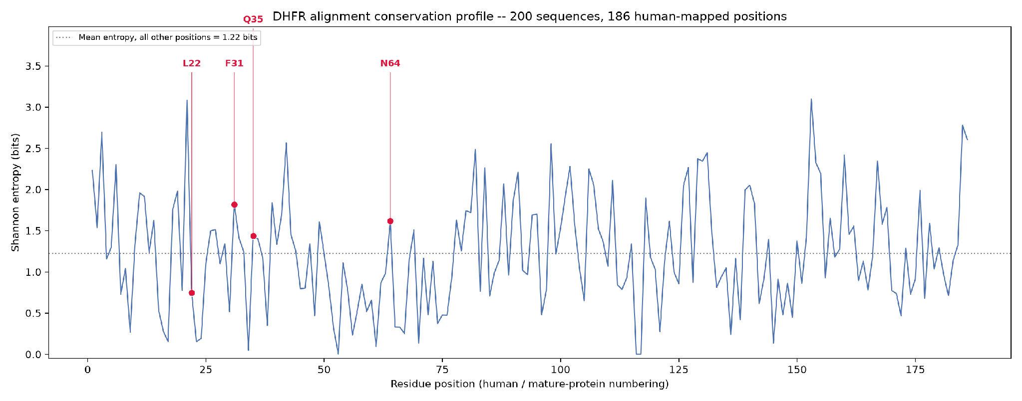
Figure 2. Three-dimensional rendering of the wild-type DHFR active site with bound methotrexate and NADPH.
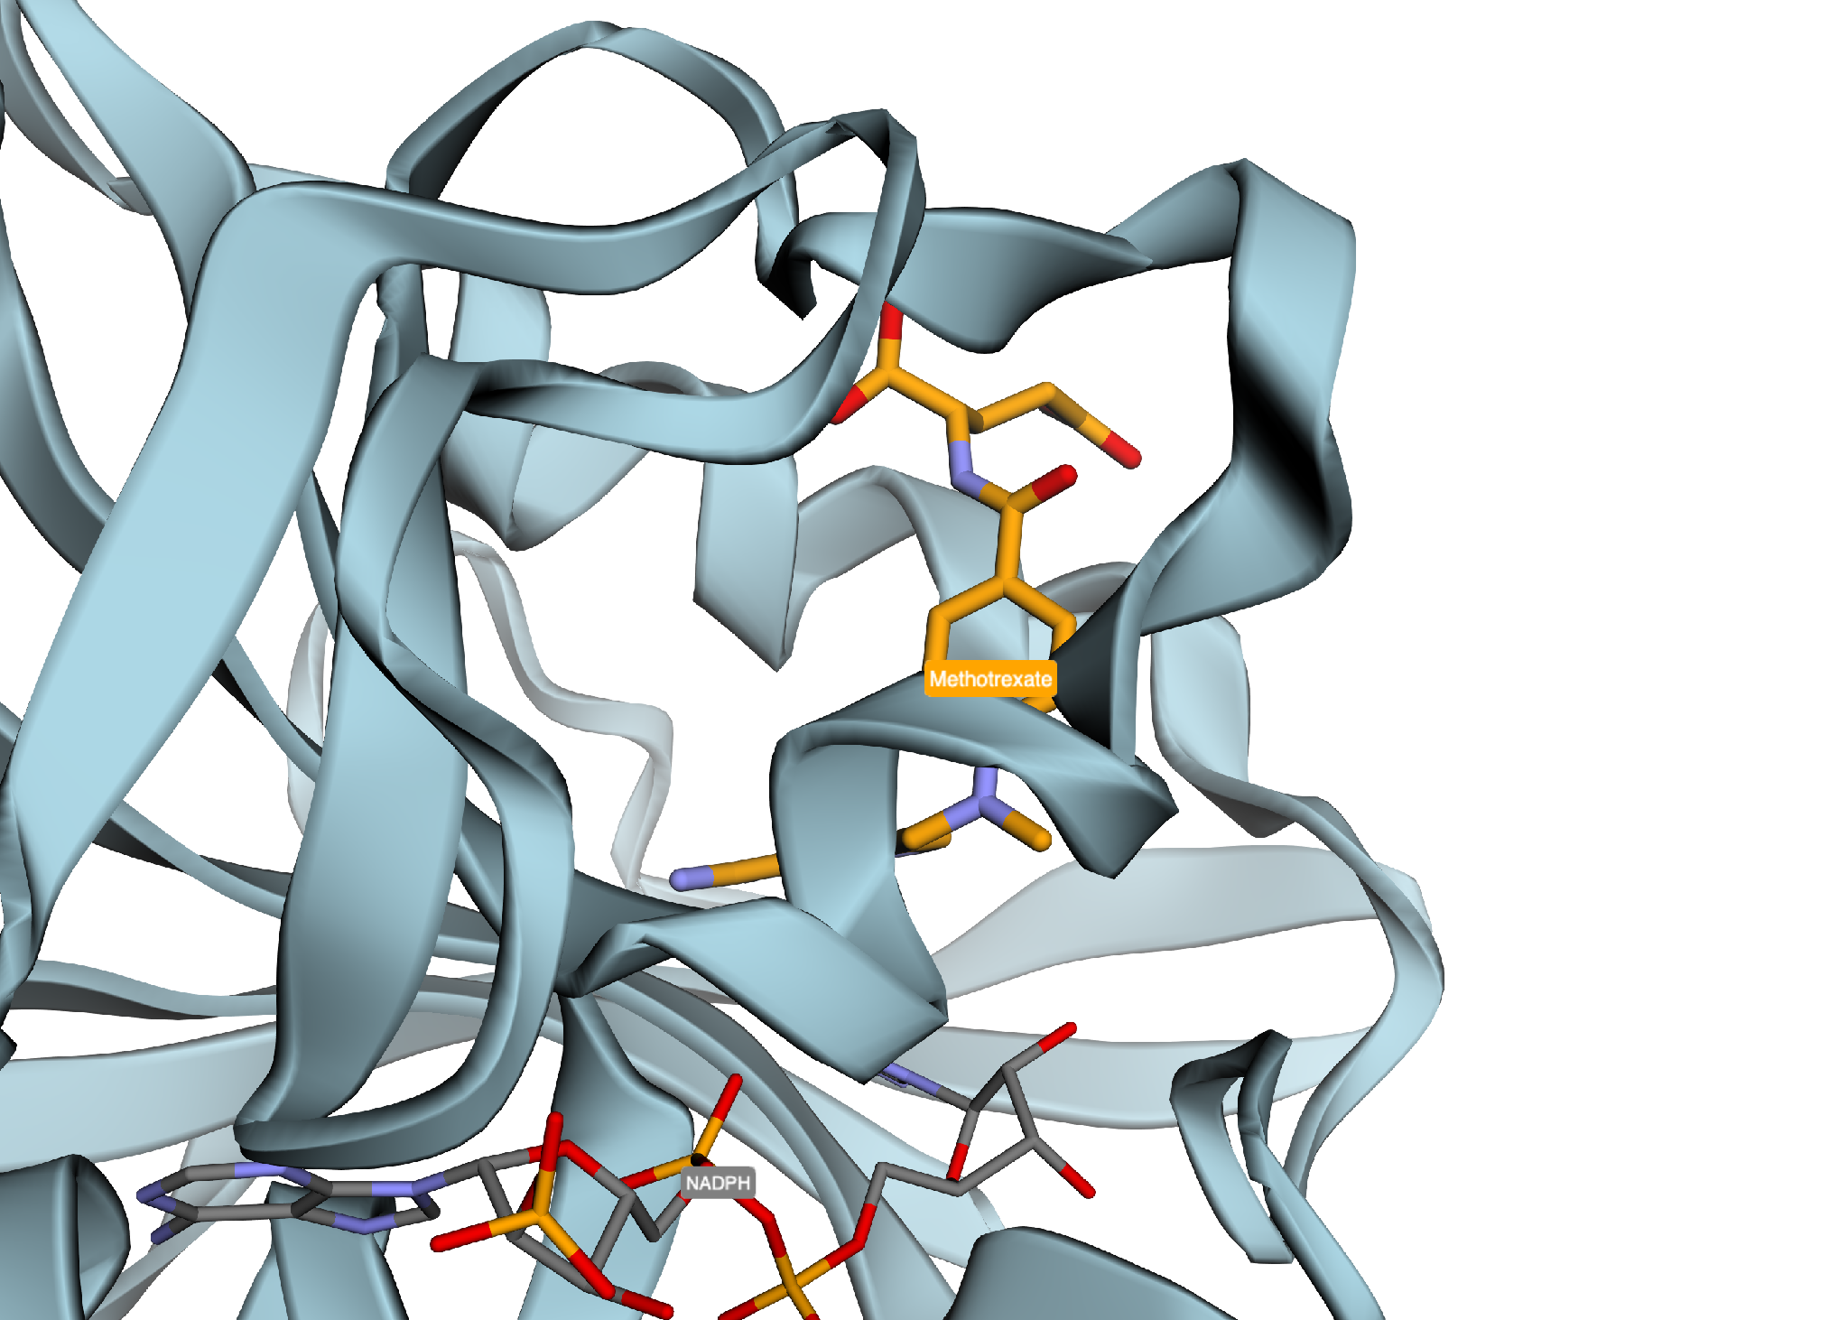
Figure 3. Full wild-type pocket scan: every residue within 8.0 Å of bound methotrexate, ranked by distance.
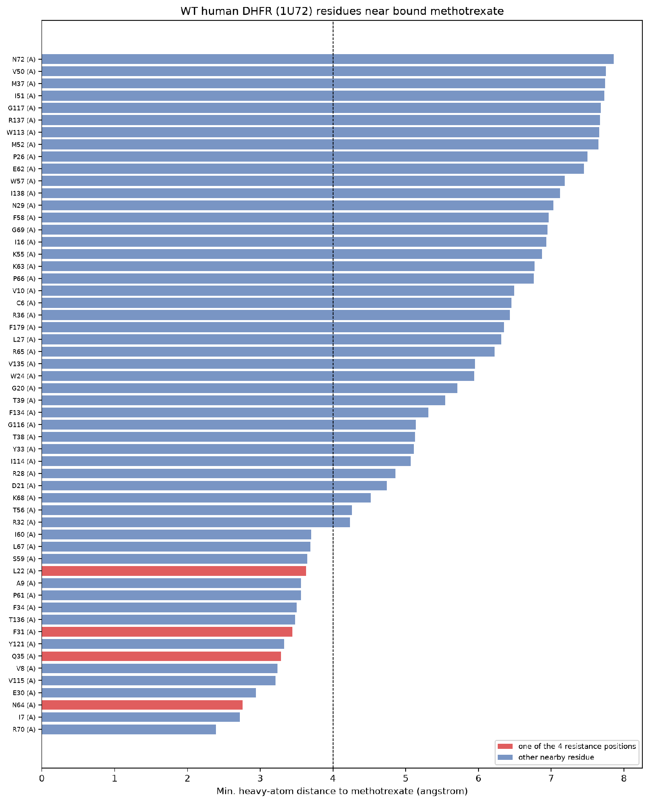
Figure 4. Three-dimensional rendering of the four resistance positions (Leu22, Phe31, Gln35, Asn64) relative to the bound methotrexate reference position.
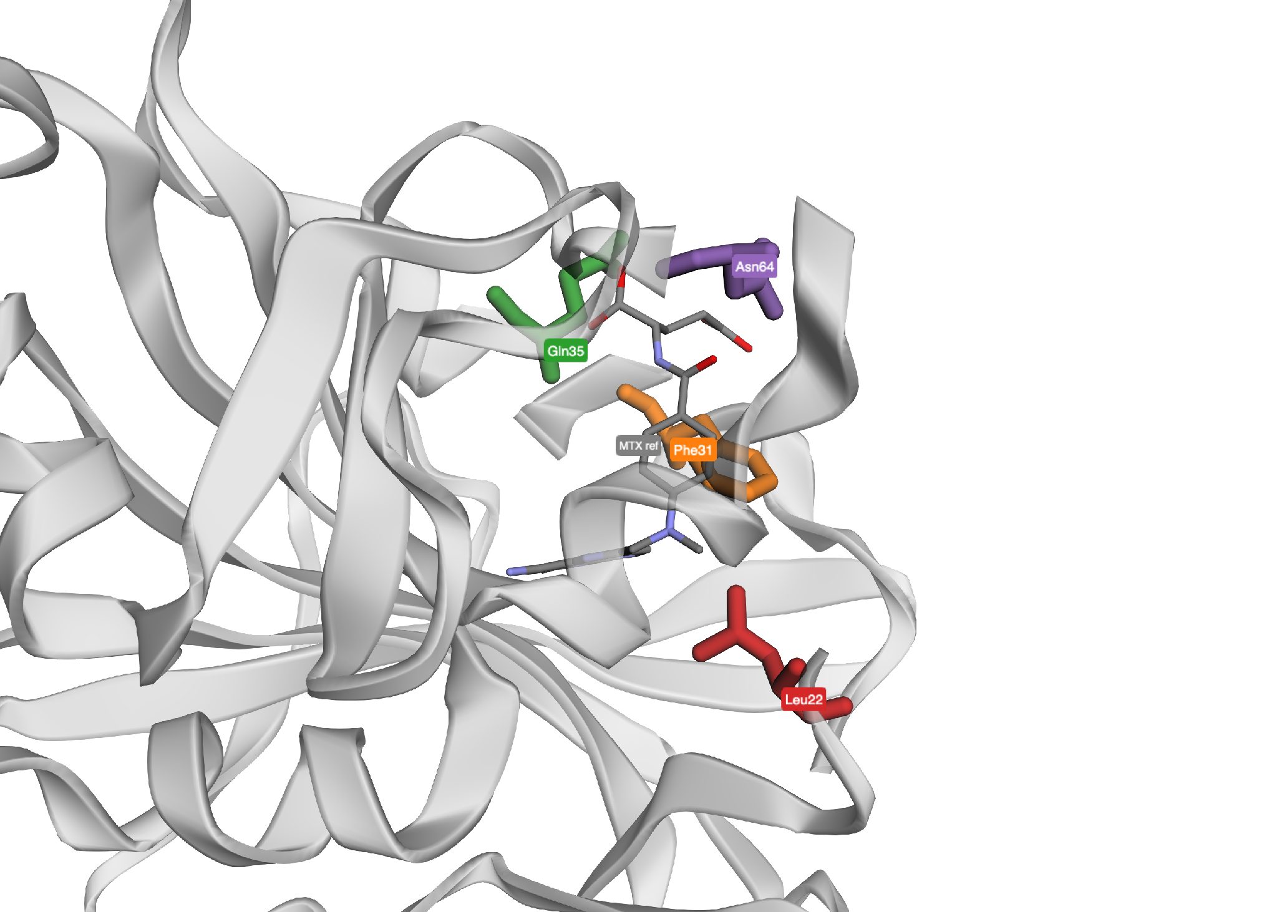
Figure 5. Wild-type redocking validation: docking score by pose rank, and pose RMSD to the crystal structure.
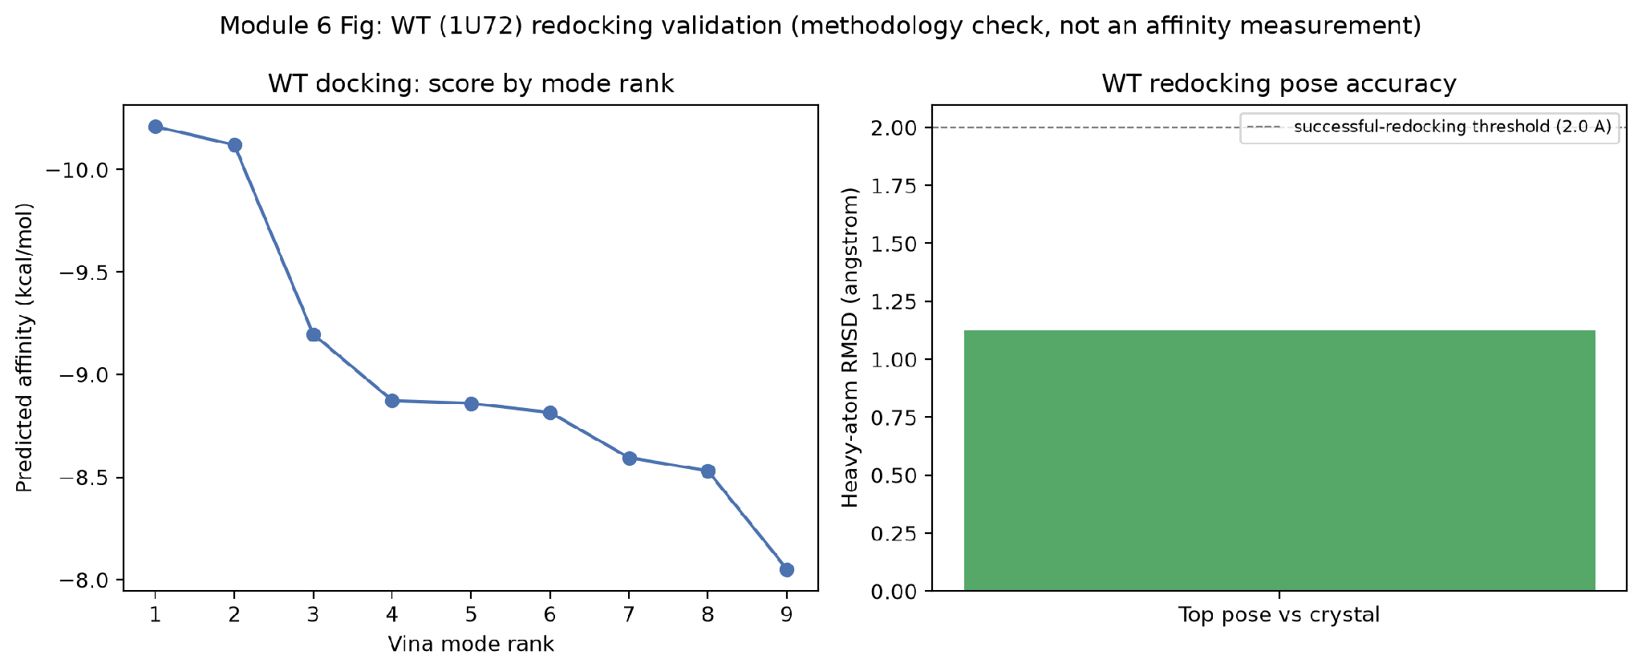
Figure 6. Docking ΔΔG (rigid and flexible receptor) versus published experimental ΔΔG for all four resistance mutants — the central test of the docking hypothesis.
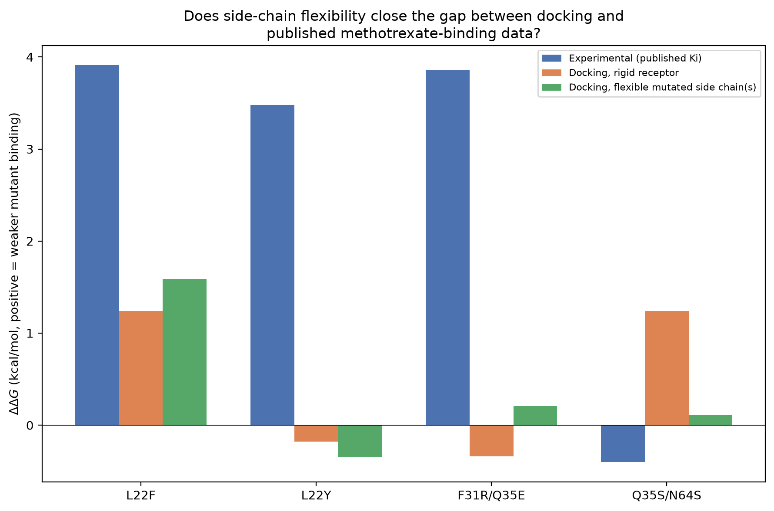
Figure 7. Volcano plot of GSE11440 differential expression (HT29 methotrexate-resistant vs. sensitive, Welch’s t-test), with DHFR highlighted.
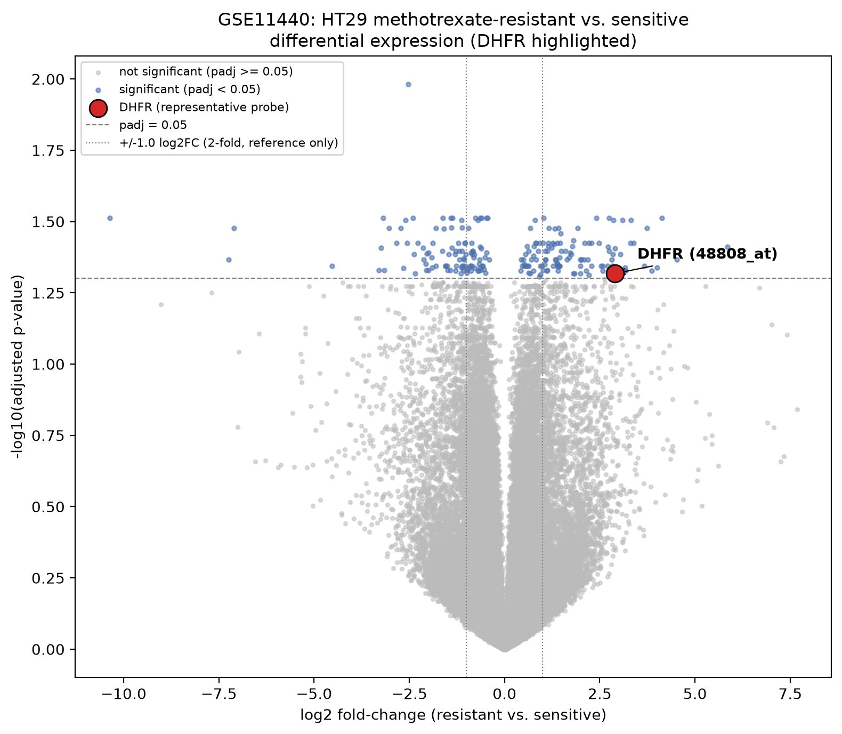
Figure 8. PCA of the top 2,000 most-variable probes (log2 signal), colored by resistance status.
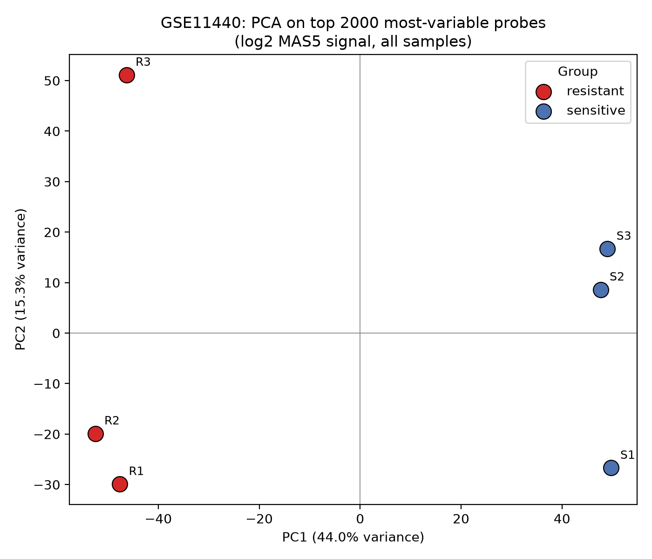
Figure 9. Clustered, per-gene z-scored heatmap of DHFR and six folate-pathway genes (TYMS, MTHFR, SLC19A1, GGH, FPGS, ATIC) across all six samples.
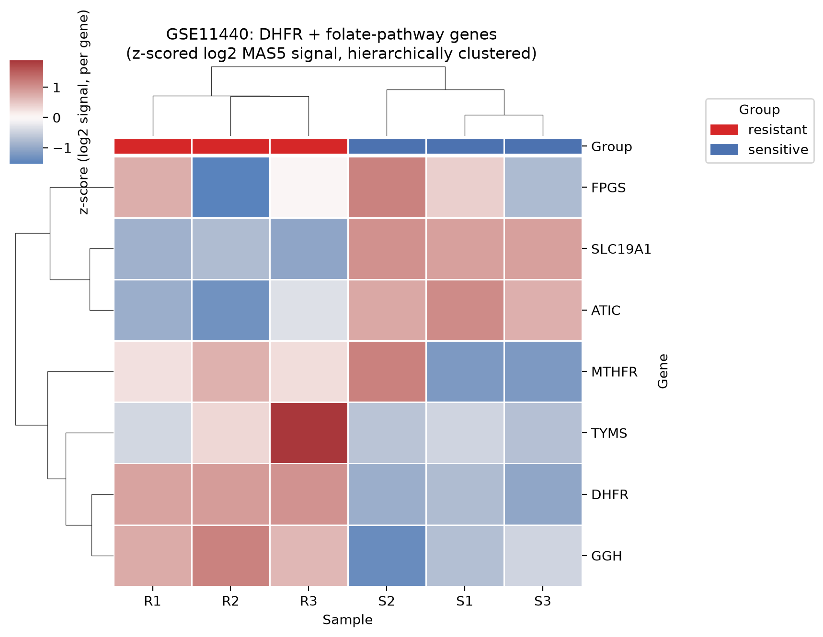

Tables
Table 1. Taxonomic composition of the expanded 200-sequence ortholog panel (Module 8)
Taxonomic group | Sequences
Other vertebrate | 123
Mammal | 34
Invertebrate | 20
Bacteria | 10
Other | 9
Fungi | 4
Table 2. Conservation at the four resistance-mutation positions, expanded 200-sequence panel (Module 8)
Position | WT residue | Shannon entropy (bits) | % identity to WT | Percentile of conservation (vs. other 182 positions) | Mean Grantham distance, natural substitutions
Leu22 | L | 0.74 | 89.3 | 76th | 46.3
Phe31 | F | 1.82 | 36.0 | 20th | 27.1
Gln35 | Q | 1.44 | 75.4 | 34th | 60.0
Asn64 | N | 1.62 | 74.6 | 26th | 108.3
Table 3. Wild-type (1U72) methotrexate contact summary (Module 5/6)
Contact type | Residue count
Direct contact (< 4.0 Å) | 17
Nearby (4.0–8.0 Å) | 39
Table 4. Resistance-position distance to bound ligand, wild-type vs. mutant structures (Module 5)
Structure | Mutation | Position | Distance (Å) | Contact type
1U72 (WT) | — | 22/31/35/64 | 3.63 / 3.44 / 3.29 / 2.76 | all direct
1DLR | L22F | 22 (mutated) | 2.96 | direct
1DLR | L22F | 35 (not mutated) | 6.41 | no contact
1DLS | L22Y | 22 (mutated) | 3.95 | direct
3EIG | F31R/Q35E | 31, 35 (mutated) | 3.45, 3.14 | direct
3F8Z | Q35S/N64S | 35, 64 (mutated) | 2.84, 4.21 | direct / van der Waals
Table 5. Physicochemical character of each substitution (Module 6)
Mutation | Charge change | Polarity change | Side-chain volume change (Å³) | Interpretation
L22F | 0 | No | +23.2 | Chemically conservative
L22Y | 0 | Yes | +26.9 | Polarity change
F31R | 0 → +1 | Yes | −16.5 | Charge + polarity change
Q35E | 0 → −1 | No | −5.4 | Charge change
Q35S | 0 | No | −54.8 | Substantial size reduction
N64S | 0 | No | −25.1 | Chemically conservative
Table 6. Wild-type redocking validation (Module 6)
Metric | Value
Docking score | −10.21 kcal/mol
Pose RMSD to crystal | 1.12 Å
Reproduces experimental pose (< 2.0 Å)? | Yes
Table 7. Docking affinities, wild-type and four resistance mutants (Module 6)
Structure | Mutation | Best affinity (kcal/mol)
1U72 | Wild-type | −10.21
1DLR | L22F | −8.97
1DLS | L22Y | −10.39
3EIG | F31R/Q35E | −10.55
3F8Z | Q35S/N64S | −8.98 (rigid)
Table 8. Docking vs. published affinity, rigid and flexible receptor (Module 6)
Mutation | Experimental ΔΔG (kcal/mol) | Rigid docking ΔΔG | Flexible docking ΔΔG | Direction match (rigid → flex)
L22F | +3.91 (lower bound) | +1.24 | +1.59 | consistent → consistent
L22Y | +3.48 | −0.18 | −0.35 | inconsistent → inconsistent
F31R/Q35E | +3.86 | −0.34 | +0.21 | inconsistent → consistent
Q35S/N64S | −0.40 (no resistance) | +1.24 | +0.11 | inconsistent → much closer to correct
Table 9. DHFR differential expression: Welch’s t-test vs. limma, all four probes on GPL570 (Modules 7, 9)
Probe | Welch log2FC | Welch adj. p | limma log2FC | limma p | limma adj. p
48808_at (representative) | 2.903 | 0.0481 | 2.903 | 1.00 × 10⁻⁵ | 0.0083
202533_s_at | 2.843 | 0.0412 | 2.843 | 1.22 × 10⁻⁵ | 0.0091
202532_s_at | 2.828 | 0.0452 | 2.828 | 2.15 × 10⁻⁵ | 0.0114
202534_x_at | 2.280 | 0.0452 | 2.280 | 2.27 × 10⁻⁵ | 0.0114
Table 10. Mutation-mediated vs. expression/amplification-mediated resistance (Modules 7, 9, 10)
Feature | Mutation-mediated | Expression/amplification-mediated
Primary level | Protein/enzyme | Cellular/gene-expression
DHFR sequence | Altered at residue 22, 31, 35, and/or 64 | Not assessed (expression-only dataset)
Methotrexate affinity per enzyme molecule | 3/4 mutants show published resistance (355–740×+ reduced Ki); docking direction-consistent for 2/4 after flexible refinement | Not addressed by expression data
DHFR abundance | Not necessarily increased | Increased 7.48× (Welch adj. p = 0.048; limma adj. p = 0.0083)
Broader pathway response | Each mutation characterized individually; no pathway-wide sequence signal tested | DHFR shift co-occurs with coordinated folate-pathway transcript changes (SLC19A1, GGH); PCA PC1 = 44.0% of variance, fully separates groups
Evidence type | Biochemical (Ki) + structural + docking | Transcriptomic (Welch’s t-test + limma) + unsupervised PCA/clustering — not copy-number/genomic
Key limitation | Docking is predictive, not a direct affinity measurement | Expression increase does not by itself establish amplification

Supplementary Material
Supplementary Figure S1. Phylogenetic tree of the legacy six-species DHFR sequence set, rooted on E. coli as outgroup, with local branch support values (FastTree-style: 0.98 eukaryote-vs-bacteria, 0.96 vertebrate-vs-fungal, 0.48 primate-vs-rodent split within mammals). Correctly recovered mammal, rodent, vertebrate, and eukaryote monophyly, consistent with known species phylogeny and confirming the legacy ortholog set was correctly assigned; superseded by the expanded conservation analysis (Figure 1, Table 1) as the primary evidence base for the conservation results reported here.
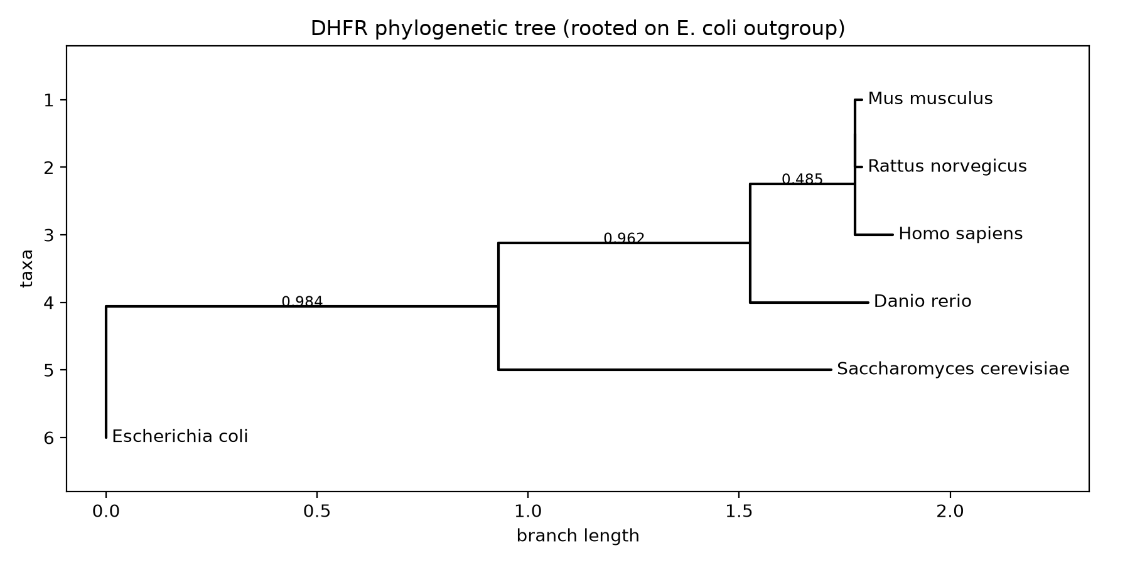
Supplementary Table S1. Legacy six-species retrieval and BLASTp homology screen, superseded by the expanded 200-sequence ortholog panel (Table 1) for the primary conservation analysis (Modules 1–2)
Species | Accession | Length (aa) | % Identity to human | Coverage | E-value | Bit score
Homo sapiens | P00374 | 187 | — (query) | — | — | —
Rattus norvegicus | NP_569084.1 | 187 | 89.84 | 100% | 2.65 × 10⁻¹³¹ | 355.0
Mus musculus | NP_034179.1 | 187 | 89.84 | 100% | 7.44 × 10⁻¹³¹ | 353.0
Danio rerio | NP_571850.1 | 190 | 61.54 | 96% | 5.12 × 10⁻⁸⁶ | 240.0
Saccharomyces cerevisiae | NP_014879.1 | 211 | 30.77 | 99% | 1.04 × 10⁻²² | 79.3
Escherichia coli | NP_414590.1 | 159 | 27.87 | 97% | 3.43 × 10⁻¹⁶ | 60.8

